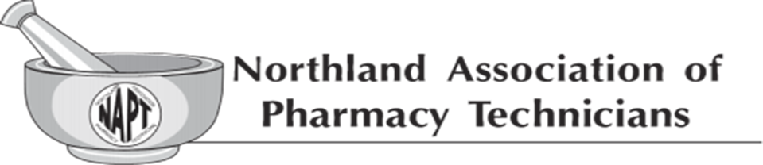
NAPT Executive Board Mini-Meeting
Via telephone
October 10, 2021, 7pm

*Amanda Olauson made it known the meeting is being recorded for the sake of taking accurate meeting minutes, using the recorder purchased for NAPT by approval of the executive board. *
Members present: Amanda (Mandy) Chase (President), Lindsay Cizek-Cribb (Chairperson), Lillie Lambert (Member-At-Large), Diane Halvorson (Treasurer/NDBOP Liaison), Patience Buck (Member-At-Large), Amanda Olauson (Secretary)
Members Absent: Adelle Casavant (Vice President), Danika Johnson (NCTC), Melissa Krava (NDSCS), Mike Schwab (NDPhA Liaison)

- Meeting called to order at 7:00pm by Lindsay Cizek-Cribb
- Quorum established by Lindsay Cizek-Cribb
- Awards- Mandy Chase will reach out to award sponsors by end of November 2021; Award info to go out in January mailer; Award due date to coincide with NDPhA’s award due date.
- Scholarships- Mandy Chase will reach out to the schools and send the scholarship application by the end of November. Acceptance of applications is January 15-30, 2022. Notifications to all applicants by March 1, 2022.
- Facebook update- Mandy Chase provided the update that Adelle Casavant will post for Pharmacy week and Pharmacy Technician Day, no stats to report. Mandy Chase will work with Adelle Casavant on postings, what to post and when.
- January Mailer- Mandy Chase stated Adelle Casavant will have this ready by next executive board meeting in December.
- Thank You postcard- Diane Halvorson updated stating the Thank You postcard has been submitted to Sir Speedy, final draft has been reviewed and approved by Diane; scheduled to mail between October 14-15, 2021 to ensure delivery by October 19, 2021 (Pharmacy Technician Day).
- CAP meeting/review- Mandy Chase/Diane Halvorson each stated this meeting (Collaboration of professionals at NDSU) went well. Mandy Chase reported she was asked questions about the Technician profession as well as NAPT and the purpose of the organization and break down of responsibilities of the positions held. Diane Halvorson stated a more thorough report will be on the December meeting agenda; she also mentioned to add the topic of mileage reimbursement for Mandy Chase’s attendance on behalf of NAPT.
- NDPhA future meetings- Mandy Chase stated Dec 8, 2021. Mandy Chase will be in attendance either in person or phone.
- Computer Maintenance- Mandy Chase completed. Computers have been returned to Amanda Olauson and Diane Halvorson. Both computers are updated to latest versions. General cleanup, malware, cookies, Avast protection renewed through 10/5/22.
- Recorder Purchase- Amanda Olauson donating the recorder; gave brief update. Lindsay Cizek-Cribb extended a Thank You for the donation.
- NAPT Guideline book update- Diane Halvorson/Mandy Chase/Amanda Olauson: Plan to meet again to review. Goal to have ready for December meeting in hopes to get finalized. Diane Halvorson will send out an email and collaborate with the committee a meeting time to wrap up this project.
- Fall Conference 2022- Diane Halvorson updated the board of the hard work already involved. Venue to be determined. Most hotels cap at 75 max capacities. Holiday Inn in Bismarck available beginning of Sept otherwise end of Oct. Ramada another option, with expenses higher-Diane Halvorson will inquire further. Ramkota not an option due to previous complaints and extensive pricing issues.
- Pins received at Board of Pharmacy #200; will last close to 1-1/2 yr. Motion made via email and will be included into December meeting.
- Diane Halvorson mentioned the ND BOP meeting scheduled January 12-14, 2022 with anticipation of the NAPT Advisory meeting likely to be held on January 12, 2022.
Meeting adjourned 7:24pm
Mini meeting minutes taken by Amanda Olauson-NAPT Secretary

