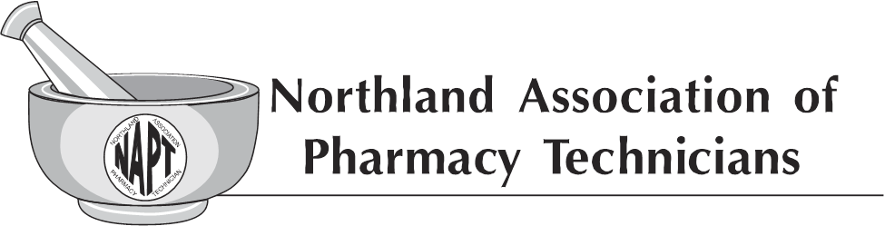
General Membership Meeting
Radisson, Bismarck ND
April 6, 2019

Members Present: 18 General Members

Meeting was called to order by Chairperson Tracy Lindsey at 12:22pm.

- Mission statement was read by Cassie Doyle.
- Tracy Lindsey declared that a quorum has been established. Agenda was accepted as is with no immediate additions.
- Introductions of current NAPT Executive Board members and introduction of Past Executive Board members were completed and the members were recognized for their involvement in the NAPT
- Treasurer’s Reports
  - Alex Spilman reviewed the current NAPT Profit and Loss statement.
  - Sharon Kupper made a motion to approve the Treasurer’s Report. The motion was seconded by Mandy Chase. Motion carried.
- Secretary’s Report
  - Lindsay Cizek-Cribb reviewed the minutes from the General Membership meeting held on October 6, 2018.
  - Diane Halvorson made a motion to approve the General Membership meeting minutes from October 6, 2018. The motion was seconded by Charity Ottmar. Motion carried.
  - It was noted that the NAPT Executive Board meeting minutes are available on the NDPhA website.
- Basket Extraordinaire Report
  - Kathy Zahn recognized the success of the Basket Extraordinaire raffle at the 2018 NAPT Fall Conference and announced that due to the participation and success, the 2019 NAPT Fall Conference will have another Basket Extraordinaire. 24 baskets were donated that resulted in $1208 being raised for the NAPT Scholarship Fund at the 2018 NAPT Fall Conference.
- 2019 Scholarship Awards
  - Unfortunately this year there were no applications submitted for the 2019 NAPT Scholarship awards. It was noted that we will continue to hold the Basket Extraordinaire at the 2019 NAPT Fall Conference and further conversations will be held regarding the NAPT Scholarship award funds should there continue to be no or limited applications submitted.
- Preferred Insurance Vendor change for North Dakota Pharmacist/Technicians
  - Tracy Lindsey provided an update that NDPhA has moved away from their endorsement with Pharmacists Mutual and have selected Superior Insurance and the Terry Richter Agency as their preferred vendors for insurance needs. Tracy Lindsey encouraged those in attendance to check with both options to see how they can help with insurance needs. It was noted that the options are available at a very affordable price.
- NAPT Annual Fall Conference 2019
  - 2019 NAPT Fall Conference will be held in Bismarck, ND at the Ramkota on September 13-14, 2019.
  - Each table received a hand out of the theme for the 2019 NAPT Fall Conference which is “Educate Before You Medicate-Knowledge is the Best Medicine”.
  - Reminder was provided that this year’s CE will be provided in three blocks: Friday evening, Saturday morning, and Saturday afternoon. Everyone is encouraged to save the date and encourage their coworkers to attend as well.
- PTCB Funding Project
  - The PTCB Partnership Funds Program provides opportunity for funds for projects aimed at promoting medication safety and advancing the roles of pharmacy technicians. PTCB offers two funding cycles each calendar year, awarding up to $10,000 to be used for direct costs associated with the development and implementation of the projected as described in the proposal.
  - Diane Halvorson provided an update regarding our application submission for a request for funding of $7200 from the PTCB Partnership Funding Program. The request is focusing on expansion of Tech-check-Tech. Diane Halvorson noted that if we are approved, the committee will be asking for additional people to be involved in the committee as well as for potential pilot sites. The overall process of the proposal is to have policy and procedures and toolkits developed, CE events, pilot pharmacy sites, and measurable outcomes of the impact tech-check-tech can have.
- Installation of 2019-2020 Executive Board
  - Installation of the 2019-2020 NAPT Executive Board was completed.
    - Chairperson—Tracy Lindsey
    - President—Arlene Monson, Not in attendance, to be installed at a later date.
    - Vice President—Lindsay Cizek-Cribb
    - Treasurer—Cassie Doyle
    - Secretary—Ashley Hogness, Not in attendance, to be installed at a later date.
    - Member-at-Large—Kathy Zahn
    - Member-at-Large—Mandy Chase
    - Parliamentarian—Autumn Guilbert
- Open mic time for members to share their thoughts, questions, requests of the board
  - Melissa Krava, NDSCS Program Director, provided an update on her continued effort in recruitment of students into the program. Several outreach methods are being utilized to continue to grow the program as Melissa Krava noted that she continues to receive calls from pharmacies stating they are looking to grow their Pharmacy Technician staff.

Meeting adjourned by Chairperson Tracy Lindsey at 12:56pm.

Meeting minutes prepared by Lindsay Cizek-Cribb, NAPT Secretary.

